

BLE-0101 Antenna Specification

Version 1.0

1. **General Information**
   1. **General product infomation**

|  |  |
| --- | --- |
| Model | BLE-0101 |
| Manufacture | RYSE Inc. |
| Address | 20 Camden St. Suite 200, Toronto, Ontario, Canada |
| Antenna Type | PCB trace |
| Test Items | Gain; Efficiency; Radiation Pattern |
| Test Frequency | 2400-2500MHz |
| Test Standard | ANSI/IEEE Std 149-1979 IEEE Standard Test Procedures for Antennas |
| Test Location | CVC Testing Technology (Shenzhen) Co., Ltd. |

1. **Test Configurations**
   1. **Test Environment**

|  |  |
| --- | --- |
| Temperature (°C) | 22.4 |
| Humidity (%RH) | 54.9 |
| Atmospheric Pressure (kPa) | 101 |

* 1. **Technical Information**

|  |  |
| --- | --- |
| Frequency Range | 2400MHz-2500MHz |
| Test Frequency | 2400MHz-2500MHz |

* 1. **Measurement uncertainty**

|  |  |
| --- | --- |
| Item | Uncertainty |
| Gain | ±0.8dB |

* 1. **Test Configurations**
  2. 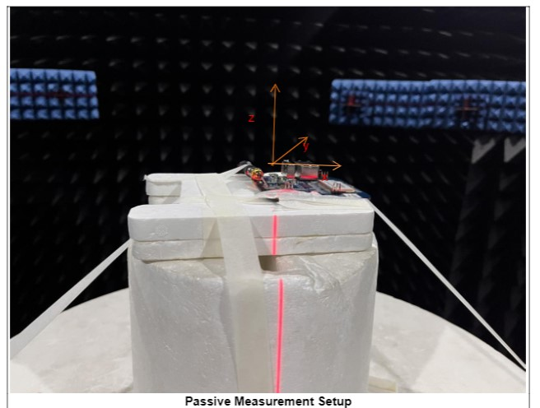**Test Principle**
  3. 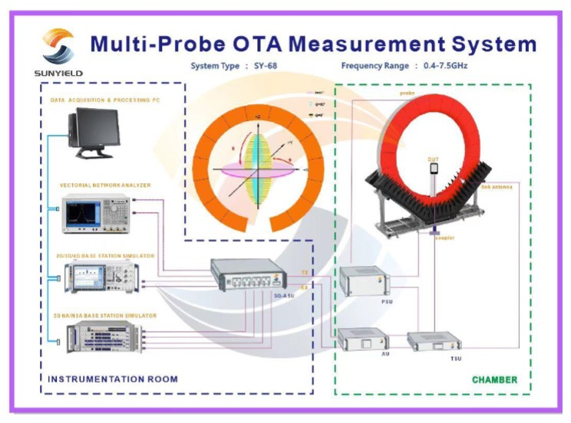**Test Equipments**

|  |  |  |  |  |  |  |
| --- | --- | --- | --- | --- | --- | --- |
| **TestEquipment** | **Equipment No.** | **Serial No.** | **Manufacturer** | **Type/Mode** | **Cal.Due** | **Using** |
| Shielded Room | CS0300038 | 20211221 | SUN YIELD | 6m*6m*6m | 2024/12/20 | √ |
| Wide band Radio Communication Tester | CS0300068 | 102635 | R&S | CMW270 | 2023/07/04 | × |
| Vector Network Analyzer | CS0300067 | 101544 | R&S | ZNB40 | 2023/06/26 | √ |
| Automatic switching Unit | CS0300039 | 81612472 | / | 5G ACTIVE SWITCHING UINT | / | √ |

1. **Test results**
   1. **Gain and Efficienty**

|  |  |  |
| --- | --- | --- |
| Test Model | BLE-0101 | |
| Sample No. | 1-1 | |
| Frequency (MHz) | Gain(dBi) | Efficiency(dB) |
| 2400 | 0.44 | -4.08 |
| 2410 | ***0.62*** | -3.93 |
| 2420 | 0.49 | -4.06 |
| 2430 | 0.35 | -4.15 |
| 2440 | 0.35 | -4.22 |
| 2450 | 0.43 | -4.15 |
| 2460 | 0.06 | -4.48 |
| 2470 | -0.12 | -4.65 |
| 2480 | -0.41 | -5.06 |
| 2490 | -0.36 | -5.09 |
| 2500 | -0.87 | -5.53 |

* 1. **Radition Pattern**

|  |  |
| --- | --- |
| 2410MHz-XOZ |  |
| 2410MHz-YOZ |  |
| 2410MHz-XOY |  |

1. **Antenna Dimension**

